**Image Processing**

M. Boddam**,** E. Lockhart, D. Toghani

Bioinstrumentation Laboratory

Department of Bioengineering, University of Washington, Seattle

**Introduction**

Presently, there are multiple ways to image a living being’s internal organs, namely imaging with x-rays, computed tomography, nuclear medicine, ultrasound, magnetic resonance, and more. In this lab report, our goal is to explore and understand magnetic resonance image processing techniques. Most of the techniques we use below can be applied to images from other modalities too. Following is a description of the processing technique.

First, we processed simple wave images to understand those techniques. Then, we processed a MRI. The technique starts with taking a spatial (2 - dimensional) fourier transform of the array of pixel values in an image. This produces horizontal and vertical spatial frequency arrays and an array of magnitude values mapped to those spatial frequency arrays. We didn’t observe the phase plots in the spatial frequency domain because they don’t give us the information required for our analysis. In this spatial frequency domain, we constructed a 2-D magnitude plot called k-space where the x-axis is horizontal contribution frequencies and y-axis the vertical contribution frequencies and the intensities of colors at each point of intersection, the magnitude. We then applied various filters to this plot. We reconstructed an image from this filtered spatial frequency magnitude plot. Comparing this with the original image helped us analyze how different filters affect an image.

**Methods**

In this lab, two different imaging processing techniques, 2D FFT and MRI image processing, are used to process images. First section uses 2D FFT image processing technique to process images. Three images of waves were downloaded from canvas website, and were used to calculate and display 2D FFT. The size of all three images were 10*10 cm. For all three images, the horizontal contribution is the x-axis, and the vertical contribution is the y-axis. 2D FFT was used to analyze how much each horizontal and vertical spatial frequency contributed to the image. For the second section, MRI image processing was used to process signals. Image ‘IMG0102’ was downloaded from the canvas website, and imported to the matlab. The size of the image is 24*24 cm, and 2D FFT of the image was calculated in matlab. Then, the higher 90 percent of spatial frequency components were removed by mask constructed in matlab, and image was reconstructed by taking the inverse 2D FFT of the lower 10 percent of spatial frequency components. Additionally, the lower 10 percent of spatial frequency components were removed by mask, and image was reconstructed by taking inverse 2D FFT of the remaining (higher 90 percent) spatial frequency components. Then, the same process was repeated for 30, 50, 70, and 90 percentage of spatial frequency components where the lower percentages were removed, and the images were reconstructed by taking the inverse 2D FFT of the remaining spatial frequency components.

**Results and Discussion**

At each point on the x-axis in Fig. 1a, there is only 1 uniform intensity of pixels. As we move to the right in the x-axis, the sum of intensity of pixels at each point on the axis stays the same, then decreases, and then it repeats. In the spatial frequency domain, this manifests in subplot 1 of Fig 1b. There are multiple frequencies that contribute to the image on the x-axis. Next, consider each section on the y-axis of Fig. 1a. Adding up all the intensities in each section produces a values that doesn’t change as we look at different sections of the y-axis. Because there are no oscillations in intensity, the vertical contributions in the spatial frequency domain only has one peak at 0 spatial frequency (subplot 2 Fig 1b). Combining these two subplots results in the 2-D FFT shown in Fig. 2c. If the two smaller non-zero magnitude frequencies were filtered out in the spatial frequency domain, then reconstructing the wave 1 would result in a image with uniform color.

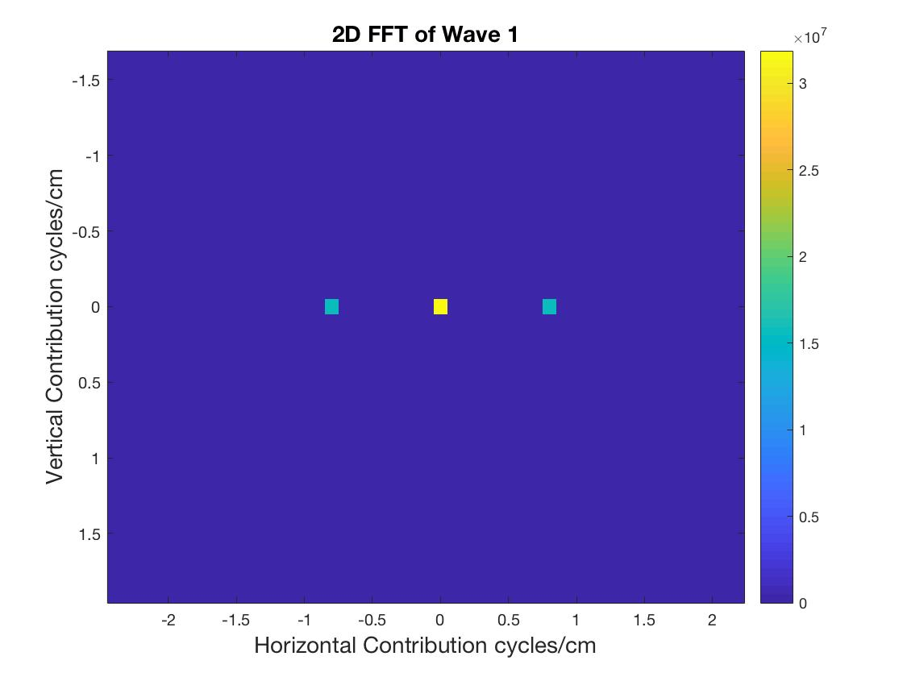



In each section of the y-axis in Fig. 2a, there is only 1 uniform intensity of pixels. As we move down on the y-axis, the sum of intensity of pixels at each point on the axis stays at a high value, then decreases, then increases to an intensity lower than the maximum, then decreases, and then this cycle repeats. In the spatial frequency domain, this manifests in subplot 2 of Fig 2b. There are multiple frequencies that contribute different magnitudes to the image on the y-axis. Next, consider each section on the x-axis of Fig. 2a. Adding up all the intensities in each section produces values that don’t change as we look at different sections of the x-axis. Because there are no oscillations in intensity, the horizontal contribution in the spatial frequency domain has only one peak at 0 spatial frequency (subplot 1 Fig 2b). Combining these two subplots results in the 2-D FFT shown in Fig. 2c. If the multiple smaller non-zero magnitude frequencies were filtered out in the spatial frequency domain, then reconstructing the wave would result in a image with uniform color. If only a couple of higher frequencies were filtered, then reconstructing the wave would result in a wave with bigger light and dark bands. If only the smaller frequencies were filtered, then the reconstructing the image would result in waves of smaller bands and smaller distance between bands of the same color.

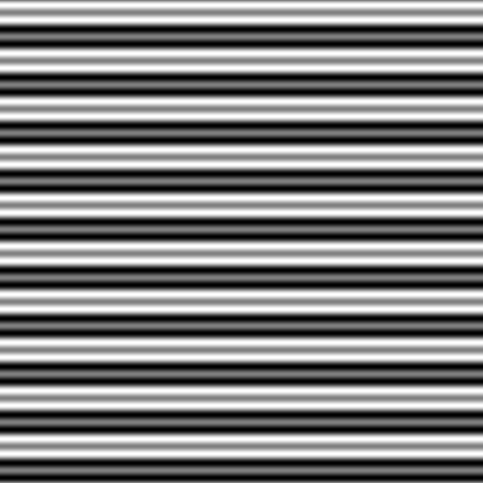

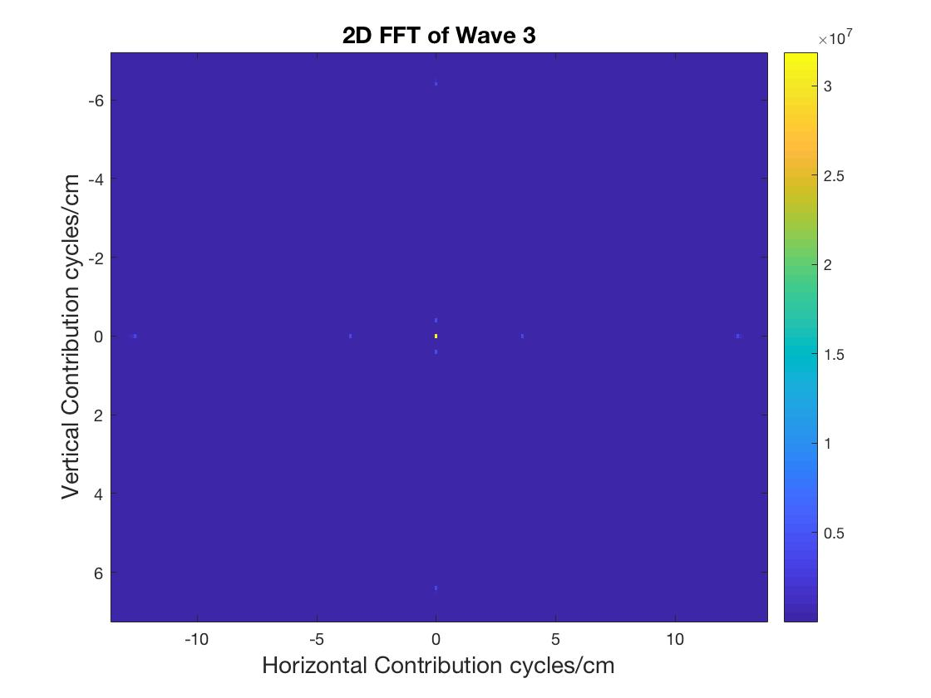

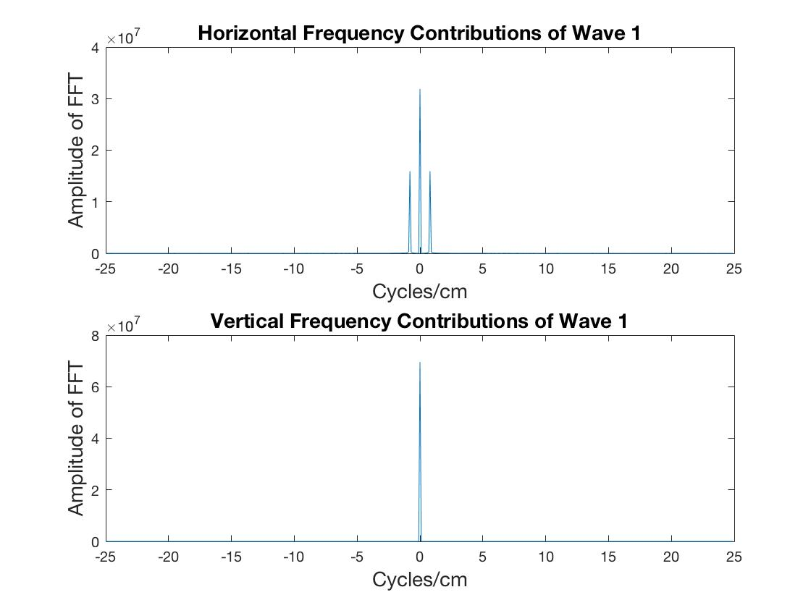

Figure 2: a) is a vertical wave, called wave 2 in the assignment b) subplot 1 is horizontal frequency contribution from 2a). Subplot 2 is the vertical frequency contribution from 2a). X-axis is the frequency in cycles/cm and y-axis is the magnitude of that frequency contribution to the image c) 2D FFT of wave 2a).

In the spatial frequency domain, subplot 1 of Fig 3b shows a peak at 0 cycles/cm and multiple smaller peaks spaced relatively far apart. In Fig 3a, these represent the changes in intensity observed when all the vertical pixel intensities at each section on the x-axis are summed. These changes in intensity are quick, so the different frequencies spread out farther in subplot 1 than in subplot 2 of Fig. 3b. Subplot 2 is the spatial frequency domain representation of the waves travelling in the vertical direction. The frequencies with non-zero magnitudes are lower than the biggest the spatial frequency with non-zero value in subplot 1. So, in the space domain image, this is represented with the large bands of lighter and darker colors in Fig 3a. Combining these two subplots results in the 2-D FFT shown in Fig. 3c. If the multiple smaller non-zero magnitude frequencies were filtered out in the spatial frequency domain, then reconstructing the image would result in a image with uniform color. If only a couple of the higher frequencies were filtered, then reconstructing the image would result in a wave with bigger light and dark bands. If only the smaller frequencies were filtered, then the reconstructing the image would result in waves of smaller bands and smaller distance between bands of the same color.

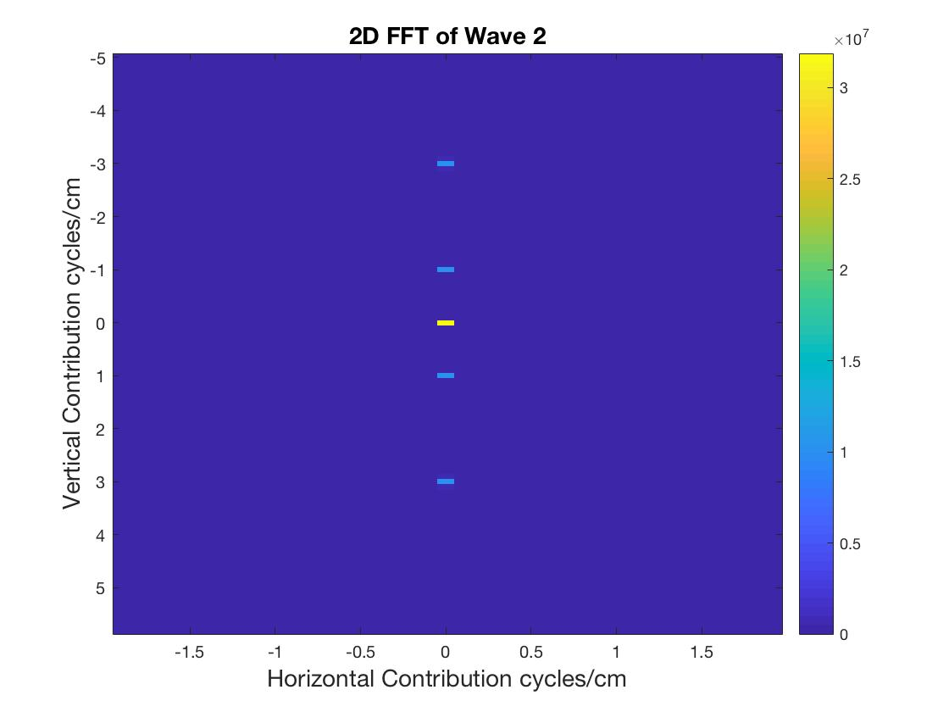

Figure 3: a) is a vertical wave, called wave 3 in the assignment b) subplot 1 is horizontal frequency contribution from 3a). Subplot 2 is the vertical frequency contribution from 3a). X-axis is the frequency in cycles/cm and y-axis is the magnitude of that frequency contribution to the image c) 2D FFT of wave 3a).

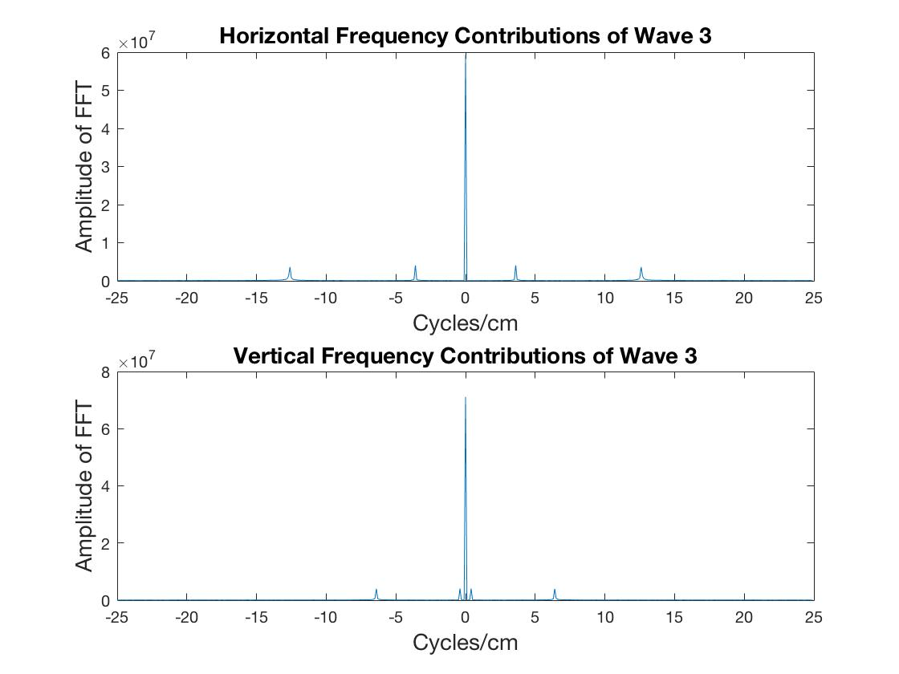

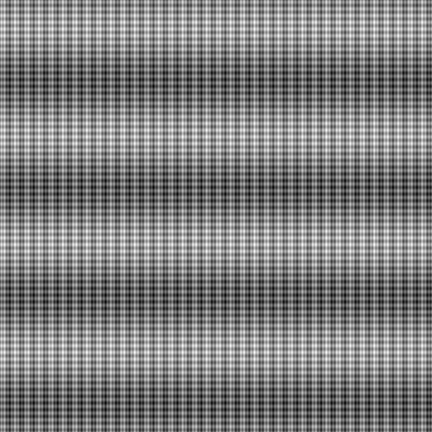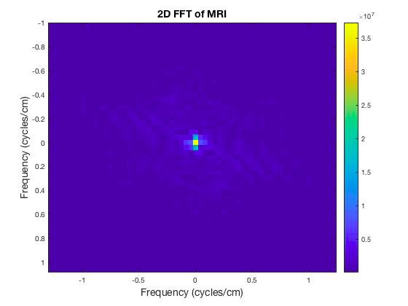

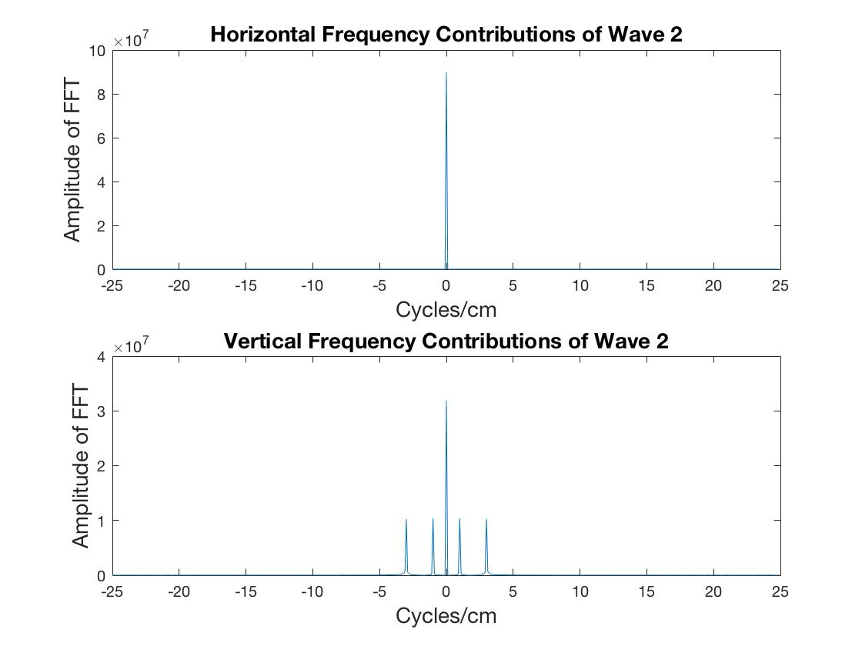

PART II

After applying the two-dimensional FFT operation to the MRI image, we observed the result shown in figure 4. In this image, spatial frequency is represented on the x and y axes, while the colors represent the contribution (magnitude) of each of these frequencies in constructing the overall image. Based on the colors shown, high frequencies did not contribute to constructing the original image as much as low frequencies did. The center of the image, corresponding to 0 cycles/cm in spatial frequency, approached yellow (high magnitude), while the surrounding area adopted a lighter purple color (low magnitude).

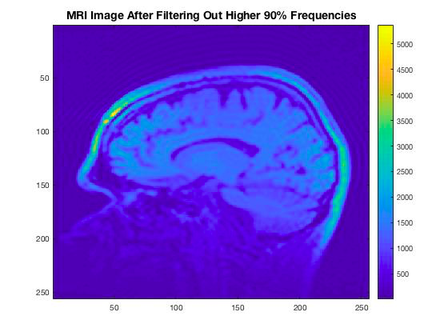 From here, we created a square masking filter with an area that comprised 10% of the image’s total area, and centered this square on the center of the 2D FFT image. Effectively, this mask, when multiplied by the spatial frequency domain representation of the MRI image, eliminated the contribution of higher frequencies which were participating in reconstructing the image. Figure 5 shows the resulting image after performing an IFFT on the filtered spatial frequency coefficients. Without the higher 90% of spatial frequencies included, most of the image was still present. This supported the observation that the K-space showed the lower spatial frequencies having higher magnitudes of contribution to creating the image than the higher spatial frequencies. As we would expect then in this case, getting rid of the higher frequencies and keeping the lower frequencies (i.e. low-pass filtering) still left the main contributing spatial frequencies to generate the image. However, the image became less sharp compared to the original MRI image (figure 6), with visible ripples emanating away from the head that would have been filled in with the more closely-spaced high-spatial frequency contributions were they still included.

Figure 5: IFFT of spatial-frequency coefficients after filtering out upper 90% spatial-frequencies. Most of the image remains. Widely-spaced ripples can be observed.

Figure 4: K-space of MRI image. Frequency (cycles/cm) on x and y axes. Magnitude of spatial frequencies is displayed in color. Yellow =high magnitude, Purple = low magnitude

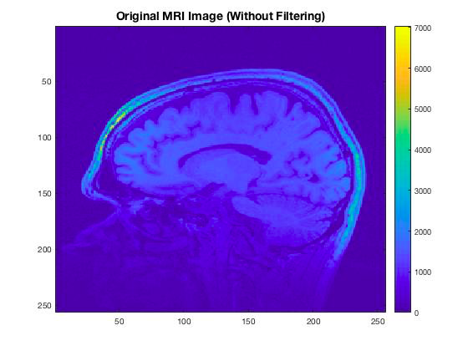 We created an inverse filter (figure 7, yellow represents passed frequencies) from the one described previously to observe the effect that came from masking the largely-contributing low spatial frequencies in the K-space. This masking filter eliminated the lower 10% of frequencies that were contributing to the image instead, leaving the upper 90% of frequencies intact. Figure 8 displays the result of applying this high-pass filter. Because the low-frequency spatial waves were of the highest magnitude in the K-space, removing them in this domain resultantly eliminated much of the image in the original image’s domain, which we found out after restoring the image with a 2D IFFT application. The upper rim of the skull surrounding the brain remained distinct, with the front of the skull remaining relatively bright in magnitude. The outline of this rim was especially present compared to the rest of the faint image.

Figure 6: Original MRI Image. All effects of masking were compared to this original image.

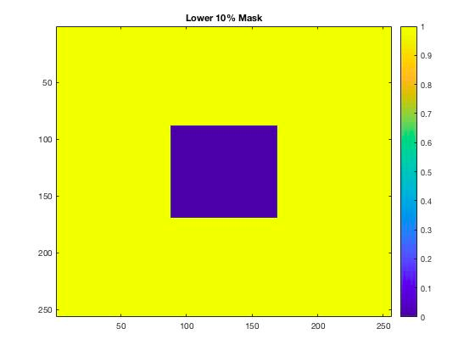 This same procedure was repeated using masking filters which individually eliminated 30%, 50%, 70%, and 90% of the lower frequencies contributing to the image in succession for analysis purposes. Figures 9-12 display the results of increasing the low spatial frequency mask’s range progressively and applying it to the original image in the K-space at each step of the progression. This steady progression revealed that the more the lower frequencies were removed, the more the detailed shapes and outlines of the image dissipated, and the individual points comprising the image were stretched. Eventually, as shown in figures 12 and 13, the image’s pixels were stretched to the point of appearing strictly vertical and horizontal. Additionally, the color representation of the magnitudes present in the image decreased in overall scale as more lower frequencies were eliminated. In the original image, the highest magnitude was represented as 7000. In the final image with 90% of the lower frequencies eliminated, the highest magnitude represented was 200. This indicated that the filtering was creating new relativity in magnitudes between the contributions of the remaining high spatial frequencies, which resulted in the brightening of the remaining pixels in the image as the filter’s influence grew. In the end, at 90% removal of lower frequencies, the areas of the image that remained were much brighter than they were initially, with the perimeter of the brain being all that 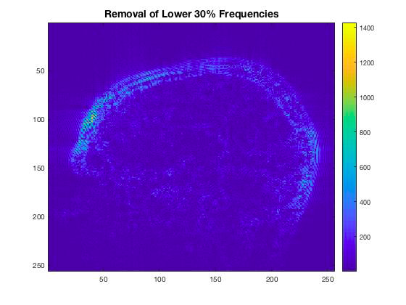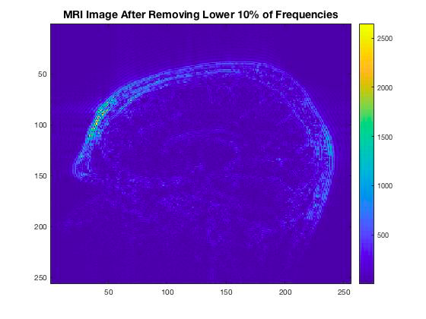vaguely remained. The high spatial frequencies 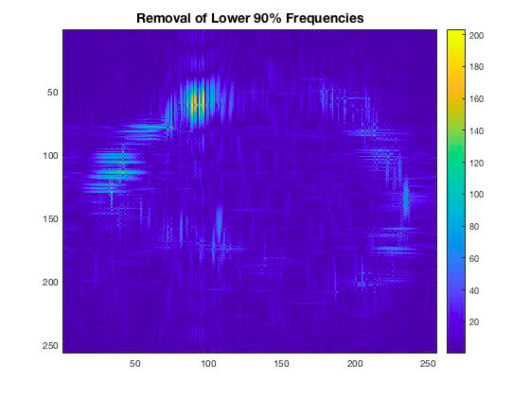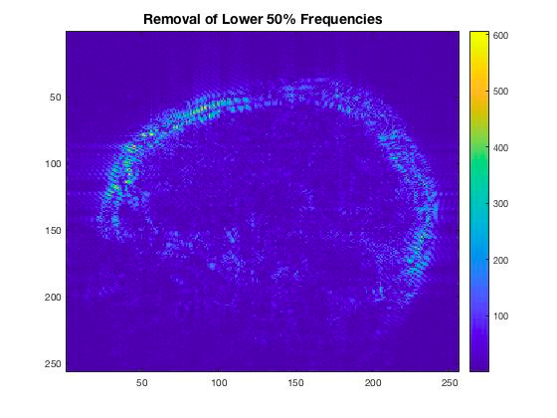in the image represented much of the perimeter of the brain.

Figure 9: Removal of 30% of lower frequencies. Total image is darker. Max gain in image of leftover components is 1400. Major features are mostly reduced. Perimeter still remains distinct.

Figure 8: Result of removing lower 10% of spatial frequencies on MRI image.

Much of inside of brain is darkened or eliminated.

Main features remain. Perimeter of head is maintained

Figure 7: 10% of lower frequencies masking filter design. Used to multiply with K-space of MRI image. Yellow indicates spatial frequencies that are kept, purple indicates those that are eliminated.

Figure 10: Removal of lower 50% spatial frequencies. Inside of brain in image is much darker. Perimeter becomes brighter in color. Pixels are noticeably stretched.

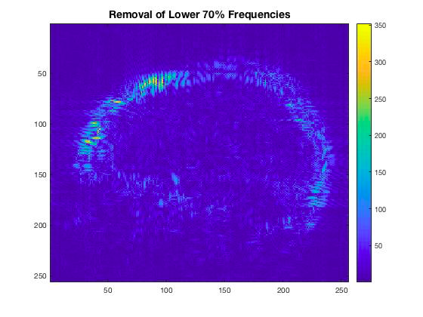





Reference:

Bashir, U. (2018). Gibbs and truncation artifacts | Radiology Reference Article | Radiopaedia.org. Retrieved from<https://radiopaedia.org/articles/gibbs-and-truncation-artifacts>

**Appendix**

clear all;close all;clc

%%% PART I

%Extract images from files

image1 = imread('Waves1(1).bmp');

image2 = imread('Waves2(1).bmp');

image3 = imread('Waves3.bmp');

%2D FFT of image 1

[Fx,Fy,im_fft] = FFT_2D(image1,10,10);

figure(1)

im=imagesc(Fx,Fy,abs(im_fft));

title ('2D FFT of Wave 1','FontSize', 14)

xlabel('Horizontal Contribution cycles/cm','FontSize', 14)

ylabel('Vertical Contribution cycles/cm','FontSize', 14)

colorbar

%2D FFT of image 2

[Fx2,Fy2,im_fft2] = FFT_2D(image2,10,10);

figure(2)

im2=imagesc(Fx2,Fy2,abs(im_fft2));

title ('2D FFT of Wave 2','FontSize', 14)

xlabel('Horizontal Contribution cycles/cm','FontSize', 14)

ylabel('Vertical Contribution cycles/cm','FontSize', 14)

colorbar

%2D FFT of image 3

[Fx3,Fy3,im_fft3] = FFT_2D(image3,10,10);

figure(3)

im3=imagesc(Fx3,Fy3,abs(im_fft3));

title ('2D FFT of Wave 3','FontSize', 24)

xlabel('Horizontal Contribution cycles/cm','FontSize', 24)

ylabel('Vertical Contribution cycles/cm','FontSize', 24)

colorbar

%Plot the horizontal and vertical spatial frequency contributions (image 1)

x_contribution1 = sum(abs(im_fft),1);

y_contribution1 = sum(abs(im_fft),2);

figure(4)

subplot(2,1,1);

plot(Fx,x_contribution1)

title('Horizontal spatial frequency Contributions of Wave 1','FontSize', 14)

xlabel('Cycles/cm','FontSize', 14)

ylabel('Amplitude of FFT','FontSize', 14)

subplot(2,1,2);

plot(Fy,y_contribution1);

title('Vertical spatial frequency Contributions of Wave 1','FontSize', 14)

xlabel('Cycles/cm','FontSize', 14)

ylabel('Amplitude of FFT','FontSize', 14)

%Plot the horizontal and vertical spatial frequency contributions (image 2)

x_contribution2 = sum(abs(im_fft2),1);

y_contribution2 = sum(abs(im_fft2),2);

figure(5)

subplot(2,1,1);

plot(Fx,x_contribution2);

title('Horizontal spatial frequency Contributions of Wave 2','FontSize', 14)

xlabel('Cycles/cm','FontSize', 14)

ylabel('Amplitude of FFT','FontSize', 14)

subplot(2,1,2);

plot(Fy,y_contribution2);

title('Vertical spatial frequency Contributions of Wave 2','FontSize', 14)

xlabel('Cycles/cm','FontSize', 14)

ylabel('Amplitude of FFT','FontSize', 14)

%Plot the horizontal and vertical spatial frequency contributions (image 3)

x_contribution3 = sum(abs(im_fft3),1);

y_contribution3 = sum(abs(im_fft3),2);

figure(6)

subplot(2,1,1);

plot(Fx,x_contribution3);

title('Horizontal spatial frequency Contributions of Wave 3','FontSize', 14)

xlabel('Cycles/cm','FontSize', 14)

ylabel('Amplitude of FFT','FontSize', 14)

subplot(2,1,2);

plot(Fy,y_contribution3);

title('Vertical spatial frequency Contributions of Wave 3','FontSize', 14)

xlabel('Cycles/cm','FontSize', 14)

ylabel('Amplitude of FFT','FontSize', 14)

%%%%%%%%%%%%%%%%%%%%%%%%%%%%%%%%%%%%%%%%%%%%%

%%% PART II

%Extract MRI image file

mr_image = dicomread('IM0102.dcm');

%Perform 2D FFT on image

[FxMRI,FyMRI,fft_MRI] = FFT_2D(mr_image,24,24);

figure(7) %Plot image

imagesc(FxMRI,FyMRI,abs(fft_MRI));

title('2D FFT of MRI','FontSize',14)

xlabel('spatial frequency (cycles/cm)','FontSize',14);

ylabel('spatial frequency (cycles/cm)','FontSize',14);

%Determine side lengths of each masking square

dim = 256^2;

Remove_10= round(sqrt(.1*dim)); %Side length of lower 10% frequencies mask

Remove_30= round(sqrt(.3*dim)); %Side length of lower 30% frequencies mask

Remove_50= round(sqrt(.5*dim)); %Side length of lower 50% frequencies mask

Remove_70= round(sqrt(.7*dim)); %Side length of lower 70% frequencies mask

Remove_90 = round(sqrt(.9*dim)); %Side length of lower 90% frequencies mask

%Create mask 1: removes the 90% higher frequencies, leaving 10% lower

%frequencies

mask1 = zeros(256,256);

mask1(88:169,88:169) = 1;

Area10_fft = fft_MRI.*mask1; %Apply Filter

ifft10 = ifft2(Area10_fft);

figure(8) %Plot filtered image

imagesc(abs(ifft10));

title('MRI Image After Filtering Out Higher 90% Frequencies','FontSize',14)

figure(9) %Plot original image

imagesc(mr_image)

title('Original MRI Image (Without Filtering)','FontSize',14);

%Remove lower 10 percent of frequencies

%Center the spatial frequency-stopping mask in middle of matrix

interval10 = [(round(128-Remove_10/2)):(round(128 + Remove_10/2))];

mask2 = ones(256,256);

mask2(interval10,interval10) = 0;

Area10_fft = fft_MRI.*mask2; %Apply filter

ifft10percent = ifft2(Area10_fft);

figure(10) %Plot filtered image

imagesc(abs(ifft10percent));

title('MRI Image After Removing Lower 10% of Frequencies','FontSize',14)

figure(11)

imagesc(mask2)

title('Lower 10% Mask')

%Remove lower 30 percent of frequencies

%Center the spatial frequency-stopping mask in middle of matrix

interval30 = [(round(128-Remove_30/2)):(round(128 + Remove_30/2))];

mask30percent = ones(256,256);

mask30percent(interval30,interval30) = 0;

Area30_fft = fft_MRI.*mask30percent; %Apply filter

ifft30 = ifft2(Area30_fft);

figure(12) %Plot filtered image

imagesc(abs(ifft30));

title('Removal of Lower 30% Frequencies','FontSize',14)

figure(13)

imagesc(mask30percent)

title('Lower 30% Mask')

%Remove lower 50 percent of frequencies

%Center the spatial frequency-stopping mask in middle of matrix

interval50 = [(round(128-Remove_50/2)):(round(128 + Remove_50/2))];

mask50percent = ones(256,256);

mask50percent(interval50,interval50) = 0;

Area50_fft = fft_MRI.*mask50percent; %Apply filter

ifft50 = ifft2(Area50_fft);

figure(14) %Plot filtered image

imagesc(abs(ifft50));

title('Removal of Lower 50% Frequencies','FontSize',14)

figure(15)

imagesc(mask50percent)

title('Lower 50 Mask')

%Remove lower 70 percent of frequencies

%Center the spatial frequency-stopping mask in middle of matrix

interval70 = [(round(128-Remove_70/2)):(round(128 + Remove_70/2))];

mask70percent = ones(256,256);

mask70percent(interval70,interval70) = 0;

Area70_fft = fft_MRI.*mask70percent; %Apply filter

ifft70 = ifft2(Area70_fft);

figure(16) %Plot filtered image

imagesc(abs(ifft70));

title('Removal of Lower 70% Frequencies','FontSize',14)

figure(17)

imagesc(mask70percent)

title('Lower 70% Mask')

%Remove lower 90 percent of frequencies

%Center the spatial frequency-stopping mask in middle of matrix

interval90 = [(round(128-Remove_90/2)):(round(128 + Remove_90/2))];

mask90percent = ones(256,256);

mask90percent(interval90,interval90) = 0;

Area90_fft = fft_MRI.*mask90percent; %Apply filter

ifft90 = ifft2(Area90_fft);

figure(18) %Plot filtered image

imagesc(abs(ifft90));

title('Removal of Lower 90% Frequencies','FontSize',14)

figure(19)

imagesc(mask90percent)

title('Lower 90% Mask')